Urinary pH Test

Subtle changes to the acid/alkaline balance of the body can have substantial impacts on a range of health conditions, including stress, bone density, pain, muscle mass and hormonal balance.

The typical Western diet produces a net acid load, which is attributed to the relatively high proportion of acid-forming meats, coupled with acid-forming starchy carbohydrates, such as pasta, rice and potato, along with energy-dense, nutrient-poor calories from fats and simple sugars. These are consumed at the expense of alkali-forming foods like fruit and vegetables. Additionally, our high intakes of sodium chloride contribute to this imbalance.
Tissue acidosis is a dominant factor in inflammation. Acidosis can contribute to osteopenia, osteoporosis and sarcopenia. It can also lead to kidney stones, and increased pain perception. Yet another aspect of the importance of maintaining the body’s acid-alkaline balance is its role in detoxification. Alkalisation of the urine can enhance toxin excretion, and small quantities of toxins may be removed over a period of time with just subtle increases of urine pH in the alkaline direction.
To manage systemic acidosis, diet must be the focus, but supplementation can support the body while dietary changes are being made.

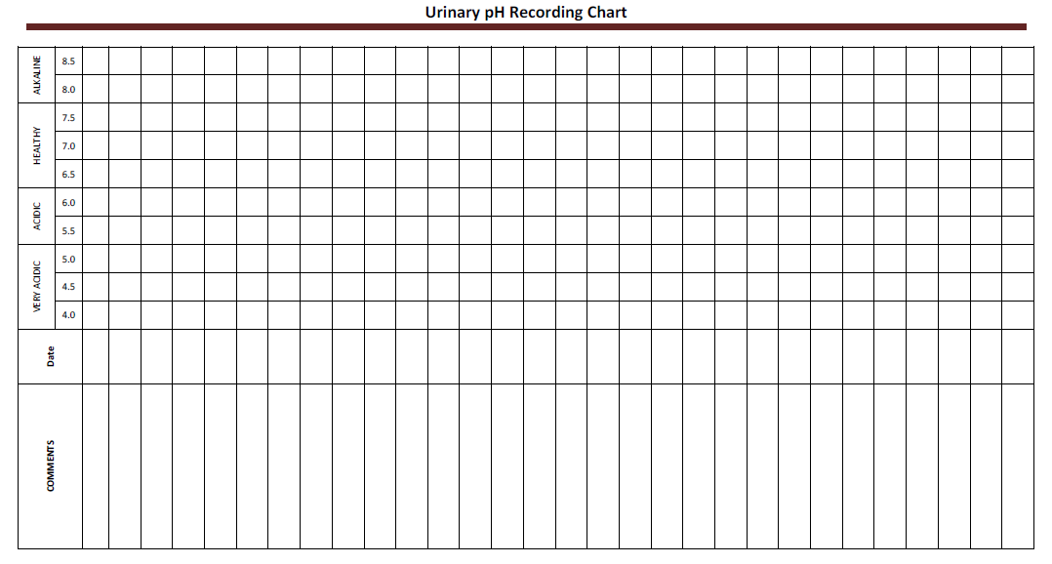
Instructions
- Hold the pH test strip in the midstream flow of your first morning urine for 3 seconds.
- Compare test strip colours to the colour chart on the pH test strip container to find the value that matches.
- Record your result for that day in the urinary pH recording chart. Mark an “X” in the box that corresponds to your urinary pH.
- Write in any comments that may be pertinent, including events from the previous day such as amount of water consumed, unusual food eaten, alcohol consumed, supplements and/or medications taken, unusual exercise etc.
- Return readings to Anne Currenti at Absolute Health & Wellbeing for assessment and further recommendations if needed. M:0417 427 938 www.ahwb.com.au
Examples of alkaline foods: most vegetables, lemon, grapefruit, wheatgrass, sprouts, almonds, flaxseeds, pumpkin or sesame seeds, green leafy vegetables like spinach, kale. . AIM TO HAVE 70% OF DIET ALKALINE FOODS
Examples of acidic foods: soft drinks, alcohol, black tea, coffee, decaffeinated drinks, artificial sweeteners, processed sugars, fructose, fast foods, bad oils, meats – especially overconsumption. More comprehensive list available on request.

